CONSIDER FOR TALK
8th Annual SEA-PHAGES Symposium Abstract
Miami University
Oxford OH
Corresponding Faculty Member: Mitchell Balish (balishmf@miamioh.edu)
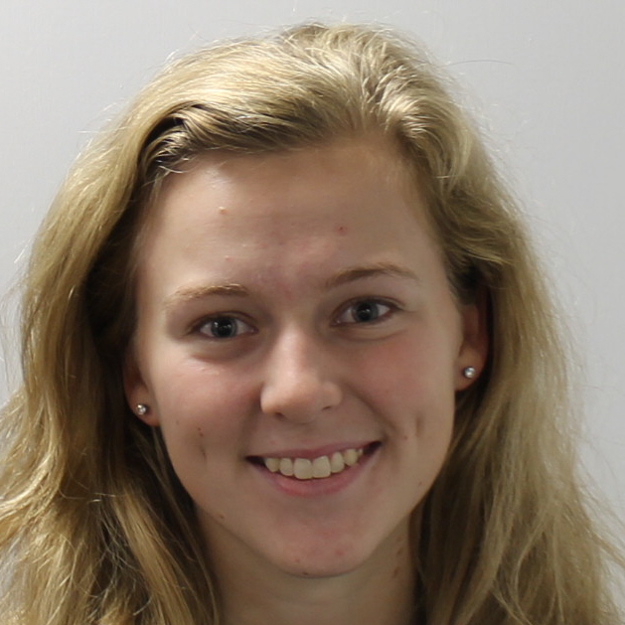
Mary Owen
Andrew Schaff
From High St. to Bishop Woods: the "Lives" of two phages
Mary Owen, Andrew Schaff, Kayla Cartwright, Angel Chen, Jessica Clark, Bradley Davis, Paige Etchison, Shelby Frieszell, Jacquelyn Gross, Stephanie Smith, Elsa Clenny, Svitlana Podolyan, Stephanie Swedik, Gabrielle Lopez, Tzvia Springer, Luis Actis, Mitchell Balish
First-year students in Miami University’s Microbiology 223/224 classes isolated and characterized the growth, appearance, and gene content of two <i>Mycobacterium smegmatis</i> bacteriophages isolated at or near Miami University’s main campus in Oxford, Ohio. The bacteriophage HighStump was found in soil close to a tree stump not far from a construction site on High Street, the main road connecting campus with the commercial center of Oxford. HighStump exhibited lytic growth and large, bullseye plaques on <i>M. smegmatis</i>, and was characterized visually by a long tail, exceeding a length of 250 nm. Analysis of its 68,821 bp-long genome placed HighStump in the B1 subcluster of mycobacteriophages, consistent with these phenotypes. With 103 genes (preliminarily), HighStump was found to be a fairly typical member of this well-characterized cluster. It had a very long tapemeasure protein, 1,991 amino acids in length, consistent with the length of its tail. The class did not identify any genes that were unique to this bacteriophage, and overall, as determined by examination of best BLAST hits, the predicted amino acid sequences of its genes had particularly strong phylogenetic relatedness to those of B1 subcluster bacteriophages Newman, Oline, and Vivaldi. Interestingly, despite the lytic growth of this bacteriophage in our laboratory conditions, the genome of HighStump included a gene potentially encoding an excisionase, suggesting that it could be lysogenic under some as-yet-unestablished set of conditions. The bacteriophage Mortcellus was cultured from soil beneath decomposing leaves in Bishop Woods, a wooded area on the Miami University main campus that was recently subjected to substantial thinning of arboreal growth and then reopened to public traffic. Mortcellus grew as pinprick plaques on <i>M. smegmatis</i> and exhibited lysogenic behavior. Like those of HighStump, Mortcellus virions had long tails, but not as long. The genome of Mortcellus was 69,800 bp in length and its nucleotide sequence clustered with the B3 subcluster of bacteriophages, despite an early prediction from DNA analysis that it was a member of cluster D. Though not currently as well-populated as the B1 subcluster, subcluster B3 is fairly replete with characterized species. BLAST analysis indicated close phylogenetic relatedness of a substantial portion of its predicted 103 genes to bacteriophages Pipefish, Phlyer, and Phaedrus. Like HighStump, there were no surprises among the Mortcellus genes in comparison with other members of its subcluster. The value of studying these organisms, aside from the educational component, is in broadening understanding of the genes common to members of the respective subclusters at the sequence level, enabling greater insight when the products of these genes are understood at the biochemical, genetic, and cellular levels in the future.

