DO NOT CONSIDER FOR TALK
2024 SEA Symposium Abstract
University of California, Los Angeles
Los Angeles CA
Corresponding Faculty Member: Amanda Freise (afreise@ucla.edu)
Khushi Bhatt
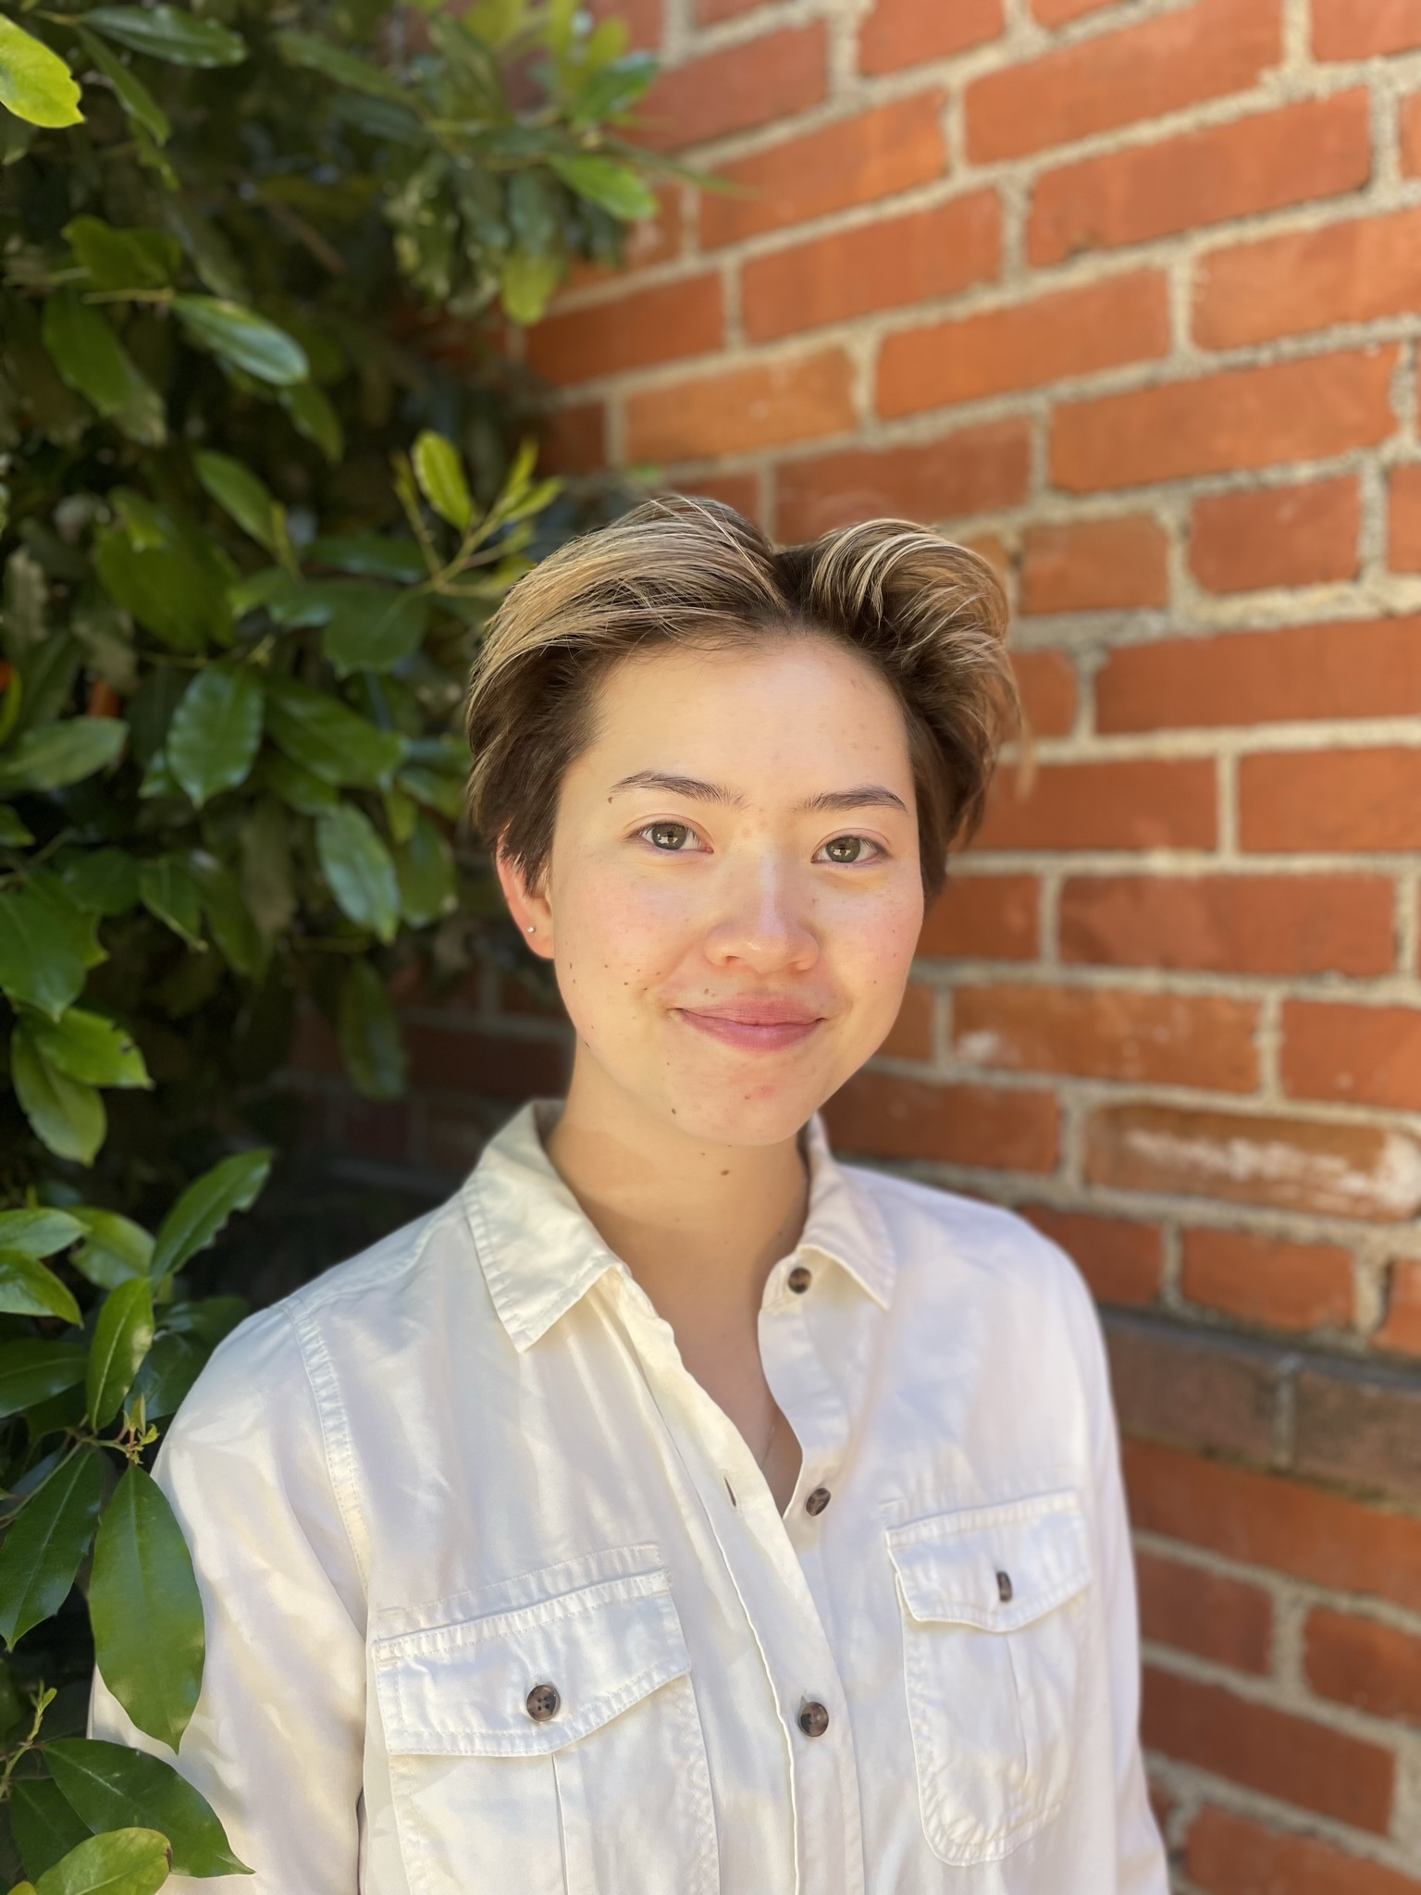
Alicia Sanoyca
Wyborn and Sicarius2 Exhibit Slight Divergence from Other Subcluster AO2 Phages
Khushi Bhatt, Alicia Sanoyca, Sebastian Castellanos, Edwin Liang, Dominic Garza, Juliet Stephenson, Michelle Zorawik, Tejas Bouklas, Amanda C Freise
Arthrobacter bacteria are important nitrogen fixers of the soil microbiome, but can have deleterious effects on the agricultural sector’s productivity by degrading herbicides. Arthrobacter phages can lyse Arthrobacter bacteria and serve as potential biocontrol interventions, but the dearth of studies investigating Arthrobacter phages presents a need for information on their genetic diversity. Presently, no comparative genomic studies have been conducted on Arthrobacter cluster AO phages. In this study, examinations of inter- and intrasubcluster genomic relationships amongst cluster AO phages were conducted, spurred by the isolation of novel subcluster AO2 bacteriophage GravityBall. Bioinformatic tools like Phamerator, SplitsTree, gene content similarity heatmaps, and Gepard dot plots were used to compare cluster AO phages to each other and to non-cluster AO genomes. It was hypothesized that phages of the same subcluster should exhibit higher genomic similarity relative to phages from different subclusters. The data partially supported this hypothesis, revealing that high intrasubcluster similarity exists amongst cluster AO phages, although subcluster AO2 phages Wyborn and Sicarius2 share less genomic similarity with other subcluster AO2 phages. In fact, analyses showed that subcluster AO1 phages were more similar to subcluster AO2 phages than Wyborn and Sicarius2 were. Subcluster AO2 phages Wyborn and Sicarius2 instead shared higher genomic similarity with each other. Further comparisons amongst cluster AS, AZ, and AO phages exhibited similar degrees of intercluster diversity. These results showed cluster AO’s previously unreported diversity and how subclustering can mask intrasubcluster genomic differences and could be periodically updated.

