CONSIDER FOR TALK
8th Annual SEA-PHAGES Symposium Abstract
Durham Technical Community College
Durham NC
Corresponding Faculty Member: Marie Fogarty (fogartym@durhamtech.edu)
Qina Mo
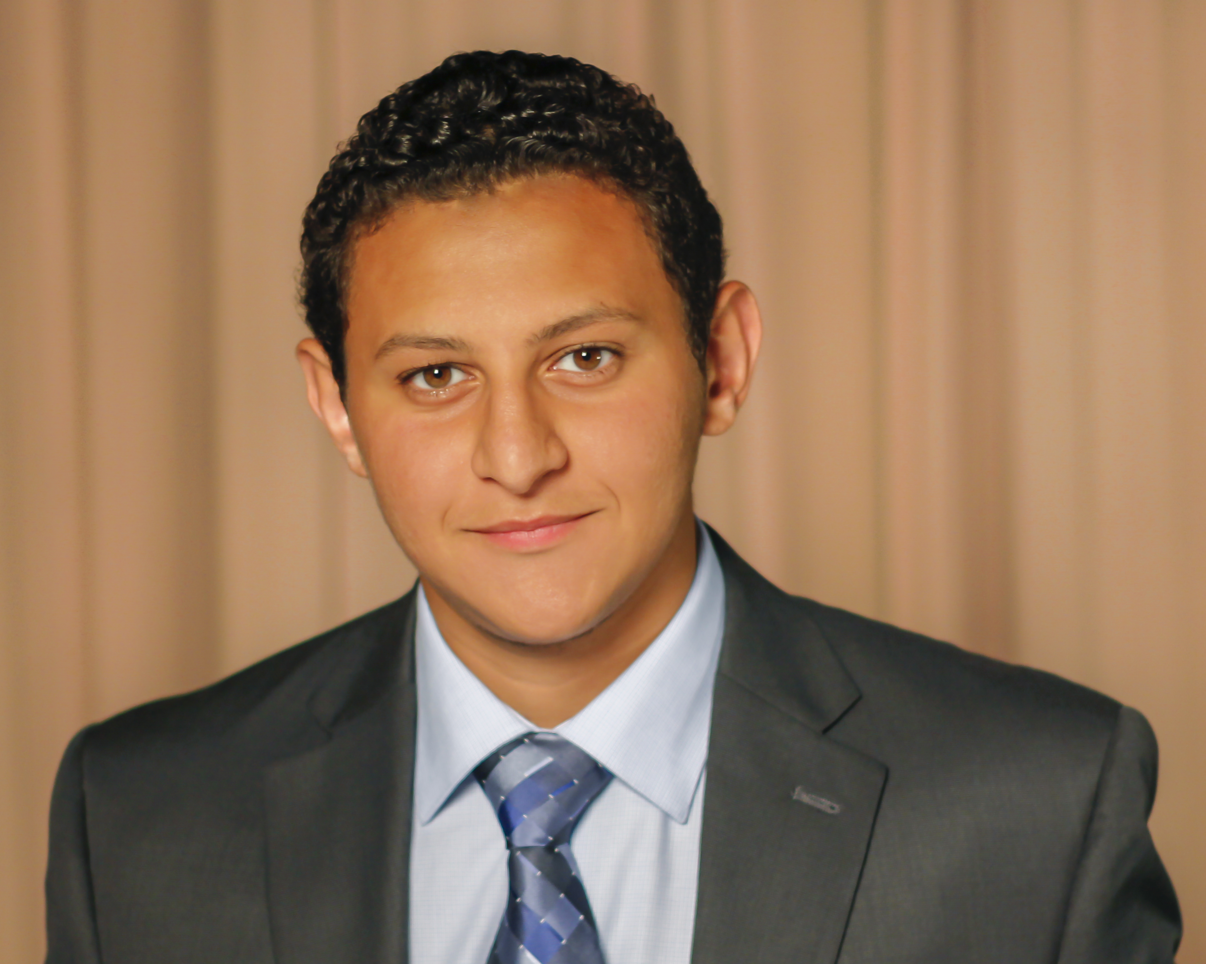
Peter Said
First in Phlight: Characterization of Two Novel Phages, Iridoclysis and Nidhogg, Isolated in North Carolina
Qina Mo, Peter Said, Kulbir S Bhullar, John S Bradford, Kenya Brown, Samuel Brown, Danny B Tshikuma, Norwood Glaspie, Rose Hylton, Bo Kim, James H Pratt, Megan L Rohland, Alan K Vedder, London Wa, Madeline O Yun, Sean Turner, Steven A Leadon, Marie P Fogarty
The world’s potentially dangerous dependence on antibiotic drugs has inspired renewed interest in the study of mycobacteriophages as an alternative to antibiotics in the fight against bacterial diseases such as tuberculosis and leprosy. In the Fall of 2015, students in the SEA-PHAGE biology lab at Durham Technical Community College used Mycobacterium smegmatis as a bacterial host to isolate two novel mycobacteriophages, Iridoclysis and Nidhogg, by enrichment. Nidhogg was found in Raleigh, NC, in a grassy, semi-fertilized area, frequently flooded with rainwater. Sequencing characterized Nidhogg as a subcluster C1 phage with 156342 bp, 65% GC content and displaying a Myoviridae morphotype. Annotation of Nidhogg identified 35 tRNAs within the genome. Iridoclysis was found on the campus of Durham Technical Community College in a flower bed. Iridoclysis is a subcluster B1 phage with 68587 bp, 66.4 % GC content and displays a Siphoviridae morphotype. Following genome annotation, wet laboratory and bioinformatics experiments were conducted to learn more about Nidhogg and Iridoclysis. Lab characterization included testing calcium requirements and temperature growth permissibility, ability to form lysogens, and effect of dehydration on phage viability. Bioinformatics experiments included identification of transmembrane proteins and start site preferences. Results suggest that Iridoclysis is calcium-dependent, with an optimal concentration of 0.5 mM yielding the most plaques. Iridoclysis demonstrated ability to grow over a range of temperatures (room temperature, 37ºC, and 42ºC) with an optimal temperature of 37ºC. On the other hand, Nidhogg showed a limited tolerance to the range of temperatures tested, only optimally producing plaques at 37ºC. Reconstituting both Iridoclysis and Nidhogg after a period of dehydration revealed a decrease in phage viability proportional to the duration of dehydration. Notably, both phages were still producing plaques after two weeks of dehydration, demonstrating their resilience to less than ideal conditions. Tests for lysogeny produced lysogens in one of three experiments performed for Nidhogg. Filtered supernatant from Nidhogg lysogens could spontaneously produce plaques when spotted on host bacteria. The ability of Nidhogg to produce lysogens is consistent with other C1 subcluster phages, which are known to produce unstable lysogens. Iridoclysis did not produce lysogens in the three experimental trials performed. Our bioinformatics inquiry identified 18 potential transmembrane proteins in Nidhogg and 10 in Iridoclysis. Two of the Iridoclysis proteins identified were the Tape Measure protein and Lysin B, while Holin was identified in Nidhogg. These initial characterization experiments provide further insight into members of the subcluster B1 and C1 phages and provide a more thorough understanding of mycobacteriophage ecological and genomic diversity.

