DO NOT CONSIDER FOR TALK
2024 SEA Symposium Abstract
Queensborough Community College
Bayside NY
Corresponding Faculty Member: Urszula Golebiewska (ugolebiewska@qcc.cuny.edu)
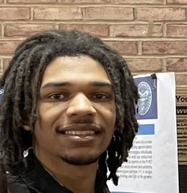
Jalen Nicolas
Pimento a typical DI phage
Jalen Nicolas, Aysha Asif, Elijah Bernard, Jennifer Bravo Cortes, Alessandra Cajahuanca, Kevin Chalen Cabrera, Samar Chaudhry, Sofia Coronado Mosquera, Louis Gouene, Emely Gracida, Michael Jaleco, Jada Lyew, Logan Sanford, Yen Yi Shak, Eva Shakarov, Ikjot Singh, Malaika Wasim, Urszula P Golebiewska
Bacteriophages—from bacterium and the Greek phagein, meaning eat—are viruses that infect bacteria. Each phage targets a specific bacterium, known as its host specie. Pimento was first isolated from a soil sample using Gordonia terrae as a host by Cameron Kedy and Hari Kotturi in 2019, at the University of Central Oklahoma; sequencing of its genome was completed at the Pittsburgh Bacteriophage Institute in 2020. Pimento has a genome of 49994 base pairs, coding for 78 genes, it belongs to the cluster DI. Queensborough Community College adopted was very happy for the opportunity to adopt Pimento. Annotation—the process of assigning potential functions to each gene—of Pimento’s genome was carried out by Honors Biology students at Queensborough Community College in Fall 2023. During annotation, students used an assortment of different bioinformatics tools—such as BLAST, HHPred and Phamerator—to locate probable homologies in the genomes of closely related phages such as NancyRae, Bock, DelRio and BetterKatz.
Of the characterized genes, most were structural in nature; proteins were found that are implicated in the construction of the tail, the capsid, and the head-to-tail complex. Many other genes coded for enzymes associated with such diverse processes as DNA replication and repair, the toxin-antitoxin system, and the lysogenic cycle. Two proteins associated with the lytic cycle were also found: lysin and holin. These proteins work in concert: lysins are hydrolytic enzymes that target and degrade the peptidoglycan found in bacterial cell walls, all the while being highly regulated by holins—so-called “protein clocks” that form tiny pores in the bacterial cell membrane, priming it for lysis.

