CONSIDER FOR TALK
2024 SEA Symposium Abstract
Northwestern College
Orange City IA
Corresponding Faculty Member: Sara Tolsma (stolsma@nwciowa.edu)
Erin Brower
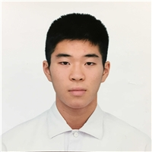
Daiki Jonouchi
Grace Anderson
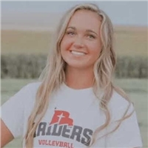
Jewel Bergstrom
Samuel Brandt
Maria Garcia
Sadie Gilmeister
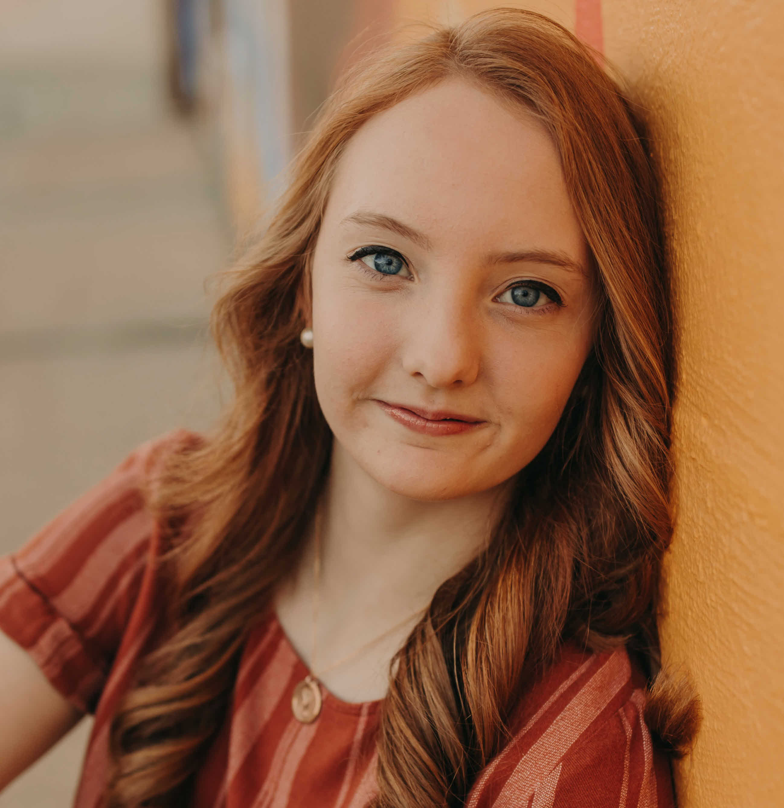
Aimee Hulstein
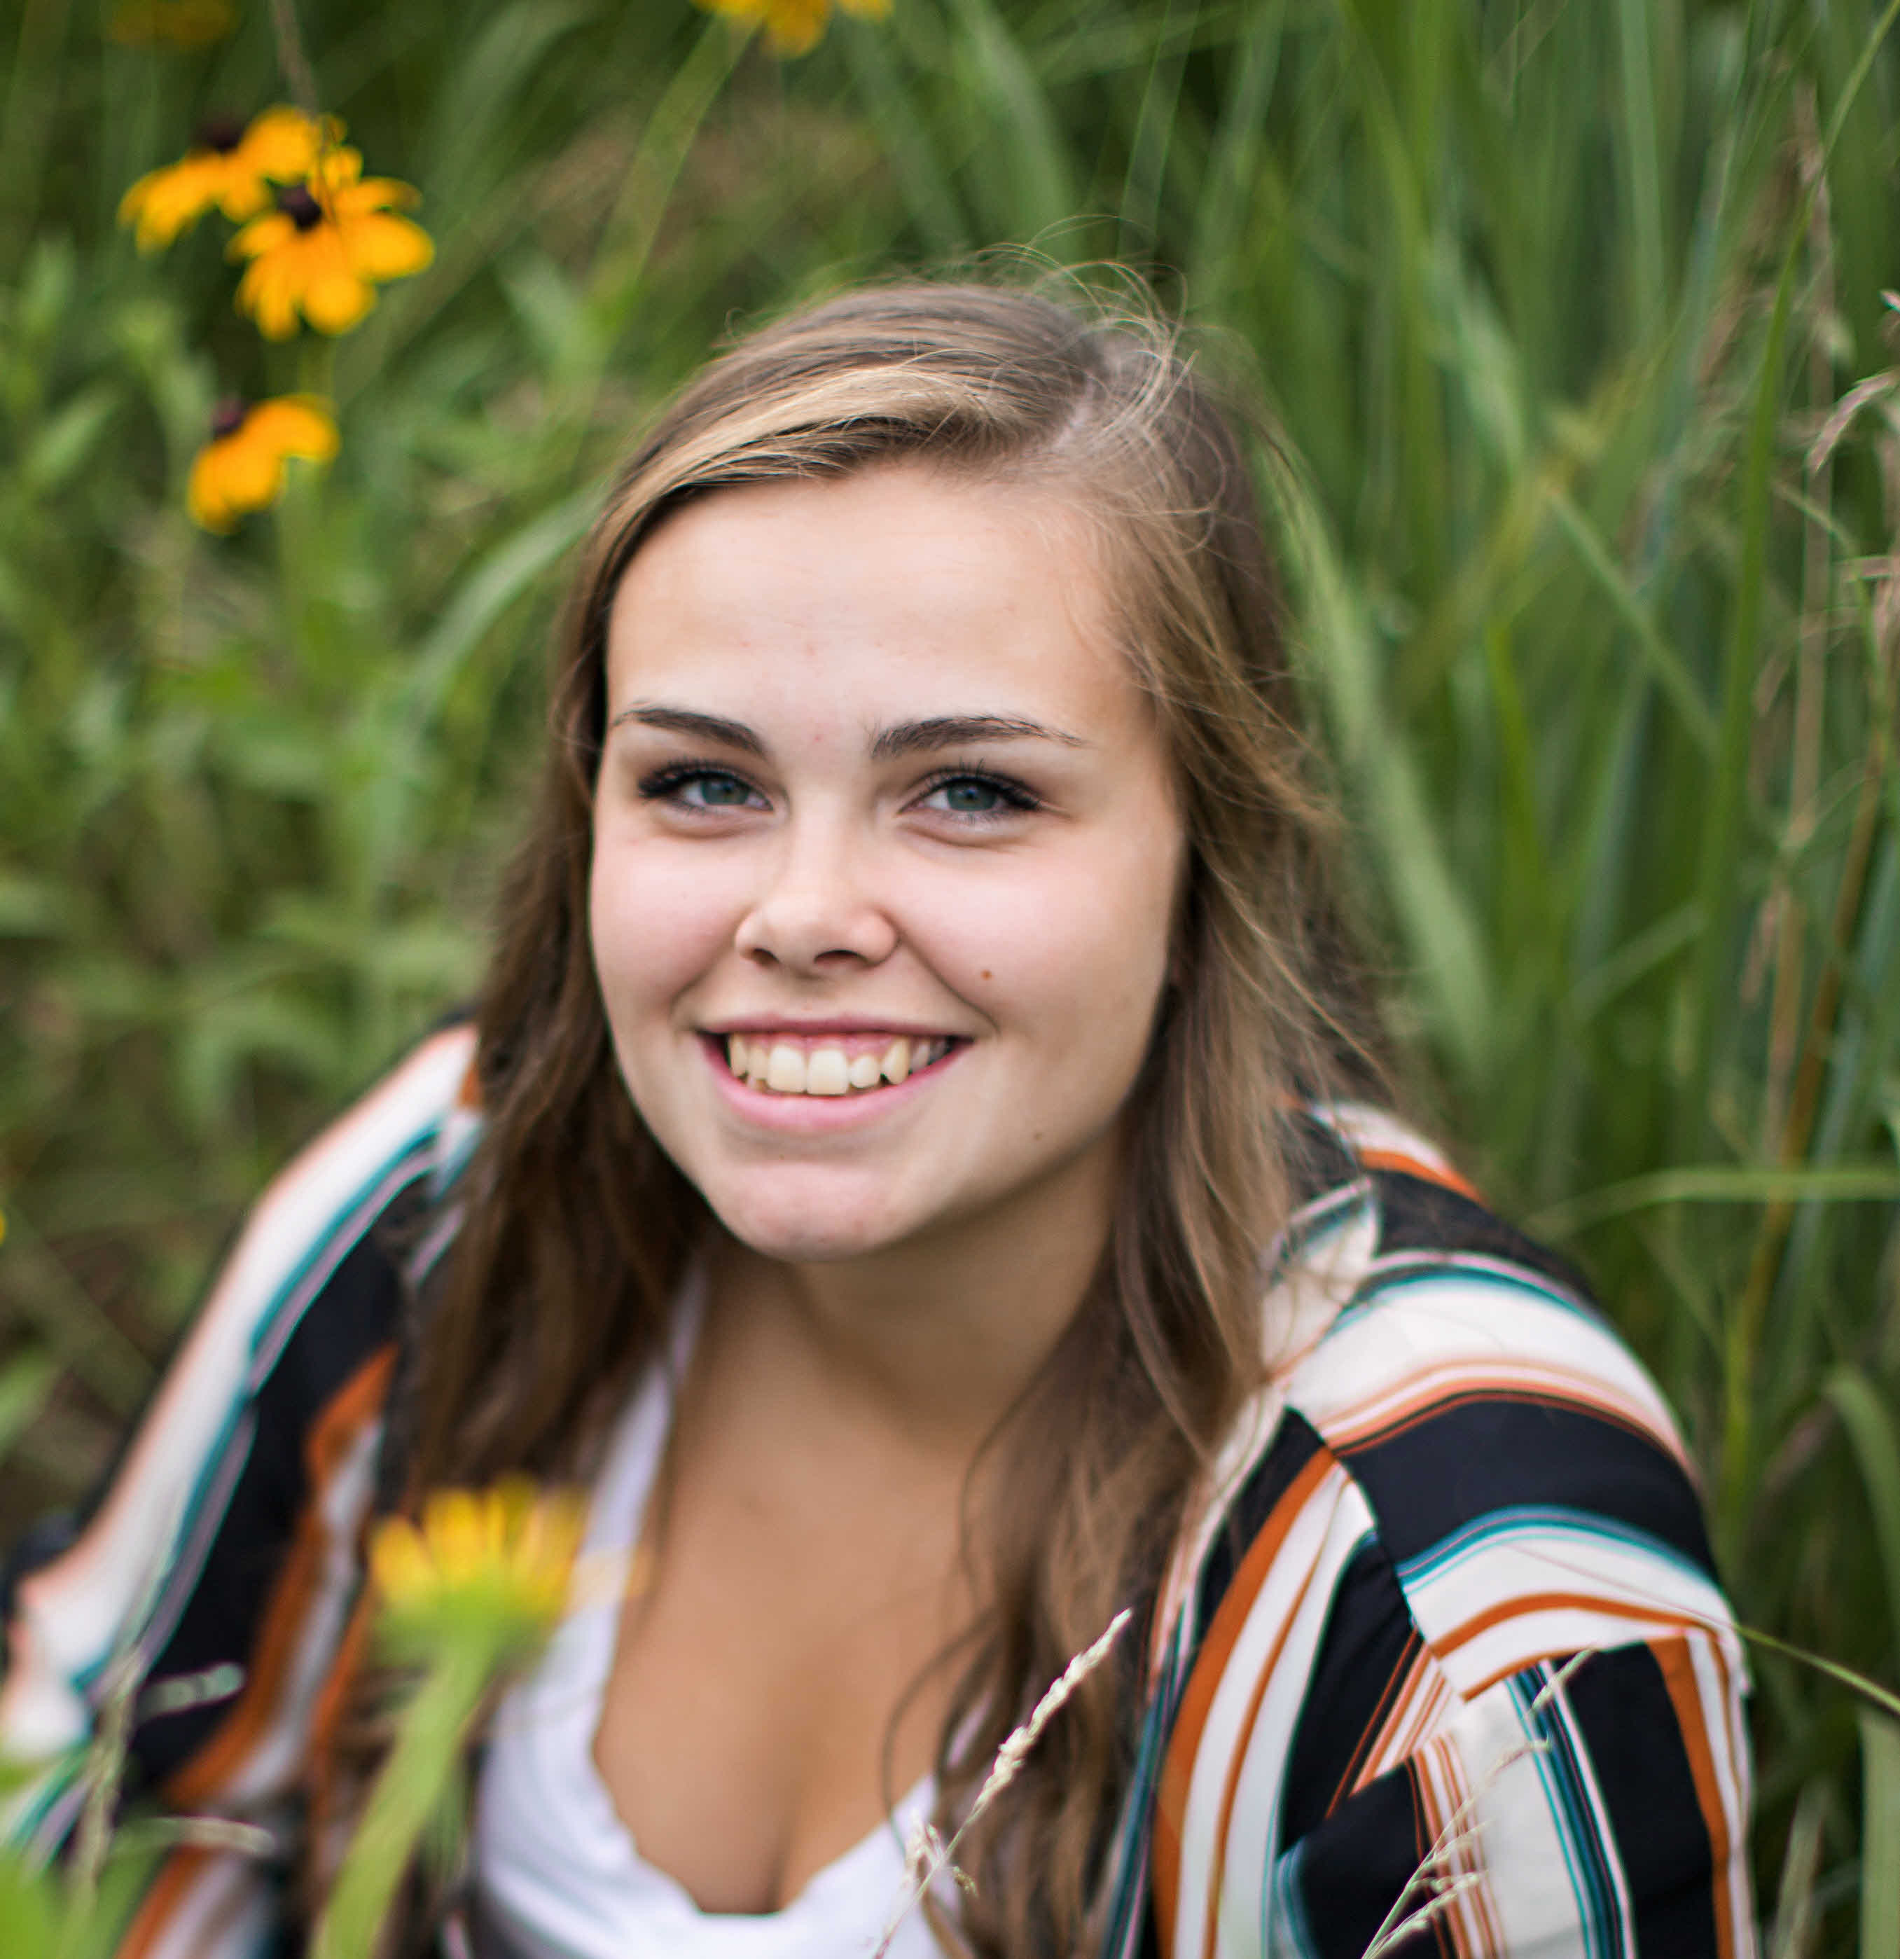
Erika McKenney
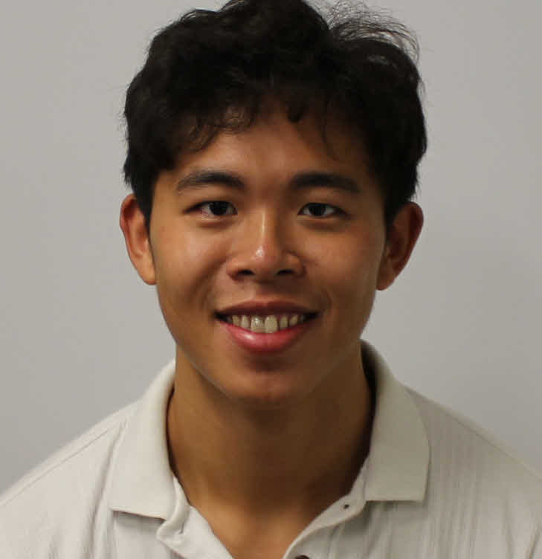
Tyler Nhan
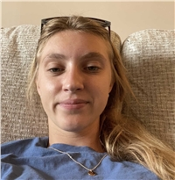
Cayli Penner
Taylor Rentschler
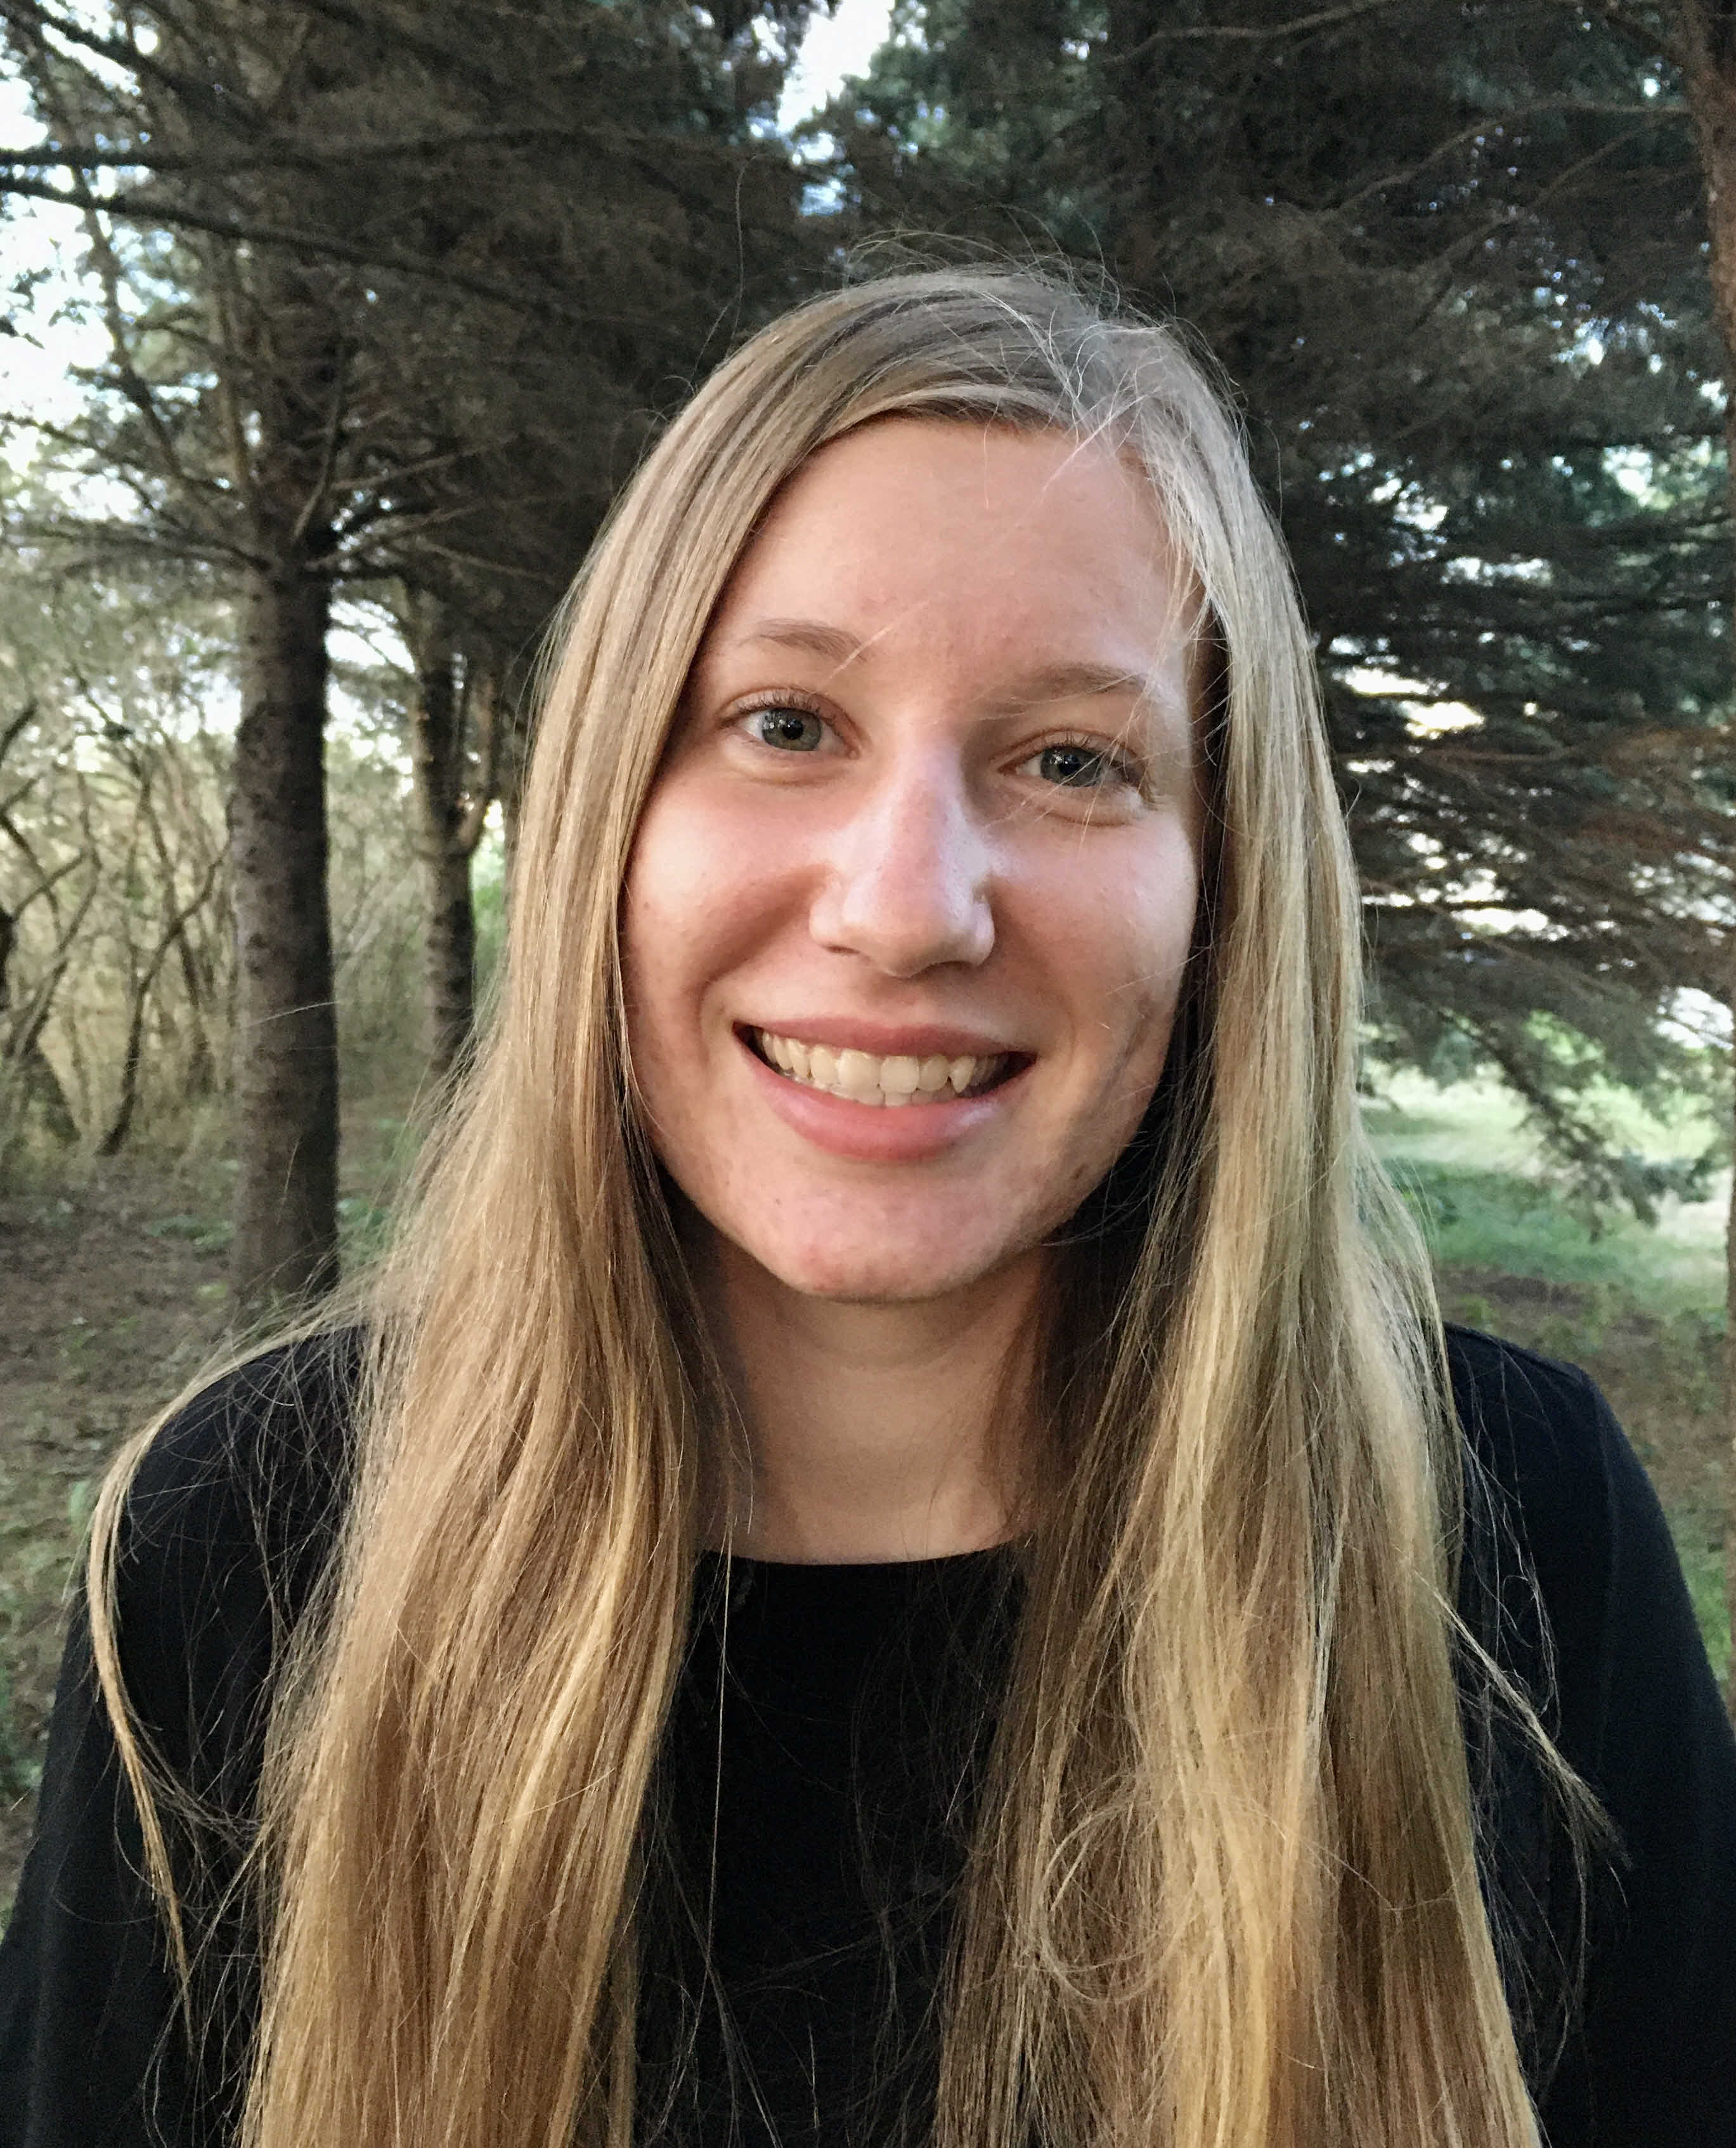
Jessica Slight
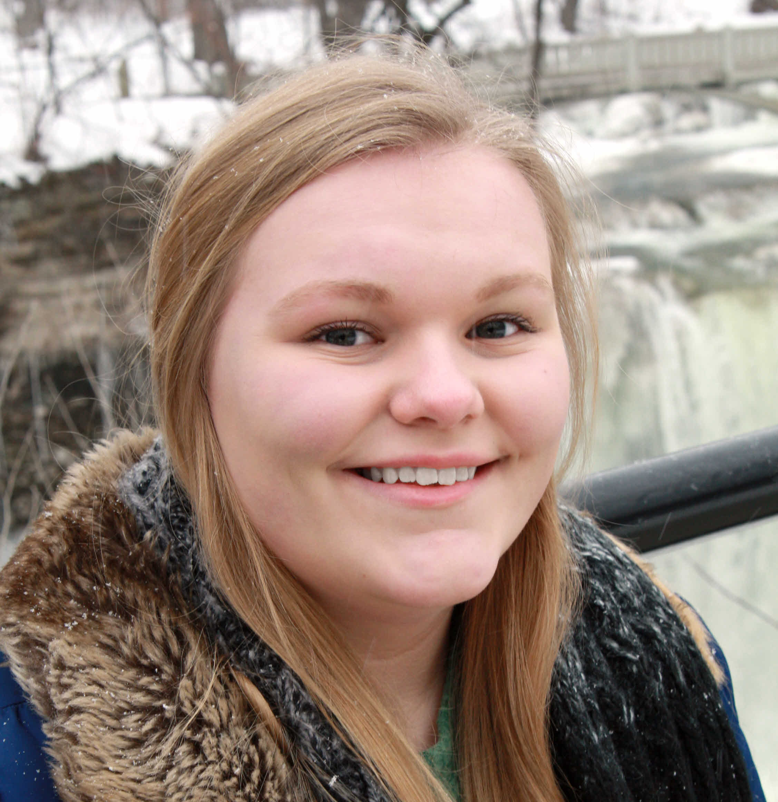
Anneka Sterk
Jacie VanderWaal
Elliana Zerr
Mousing Around with Bacteriophages: A Genetic, Biochemical, and Immunological Comparison of Island3 and Sbash
Erin Brower, Daiki Jonouchi, Grace Anderson, Jewel Bergstrom, Samuel Brandt, Maria Garcia, Sadie Gilmeister, Aimee Hulstein, Erika McKenney, Tyler Nhan, Cayli Penner, Taylor Rentschler, Jessica Slight, Anneka Sterk, Jacie VanderWaal, Elliana Zerr, Sara S Tolsma
Bacteriophages are viruses that infect bacteria. They can be used in phage therapy to combat bacterial infections resistant to traditional antibiotics. One limitation of phage therapy is the lack of understanding about phage genetics and biochemistry. We can learn more about bacteriophages by studying their genetic and biochemical relationships. As part of the SEA-GENES Program, we are conducing systematic genetic screens of Island3 and Sbash phages. We are cloning each gene in the phage genomes, transforming the host, M. smegmatis, with each gene, overexpressing each gene in the host cells, and assaying for altered host cell growth (cytotoxicity) and the ability of the phage gene product to protect the host from infection by another phage (defense). Additionally, we are raising antibodies in BALB/c mice against Island3 and Sbash as well as against ~71 kDa proteins from each phage separated by SDS-PAGE and eluted from the gels. We are using our antibodies in Western blot analyses to better understand biochemical relationships between Island3, Sbash, and several other bacteriophages that infect Actinobacteria.

